Experiment 11: Create a dataframe of ten rows, four columns with random values. Convert some values to nan values. Write a Pandas program which will highlight the nan values.

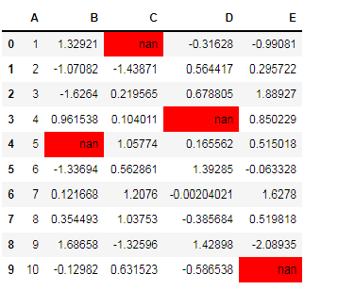

Program:

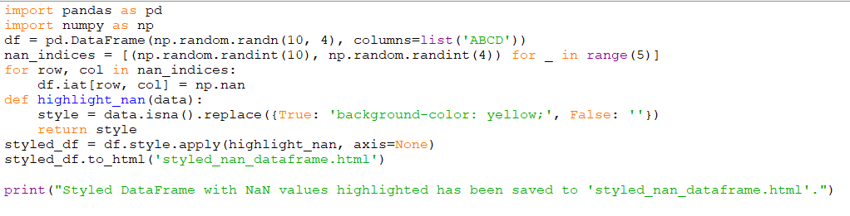

Output:

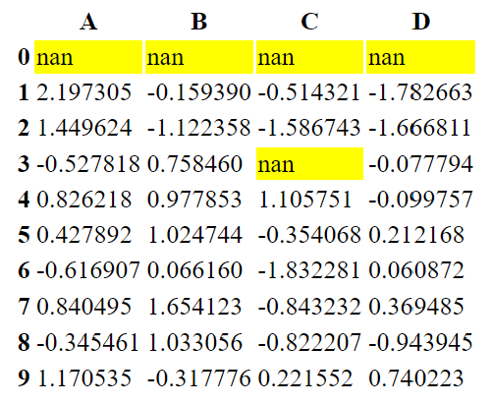

Experiment 12: Create a dataframe of ten rows, four columns with random values. Write a Pandas program to set dataframe background Color black and font color yellow.

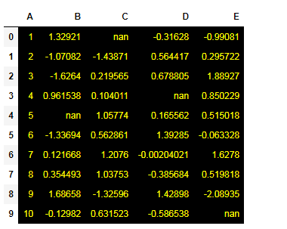

Program:

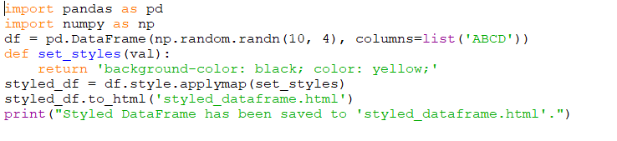

Output:

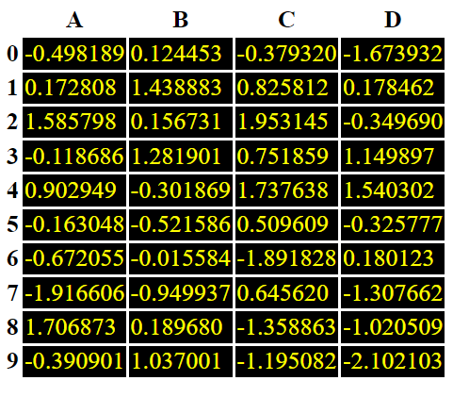

Experiment 13: Write a Pandas program to detect missing values of a given DataFrame. Display True or False.

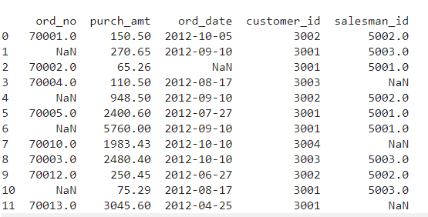

Program:

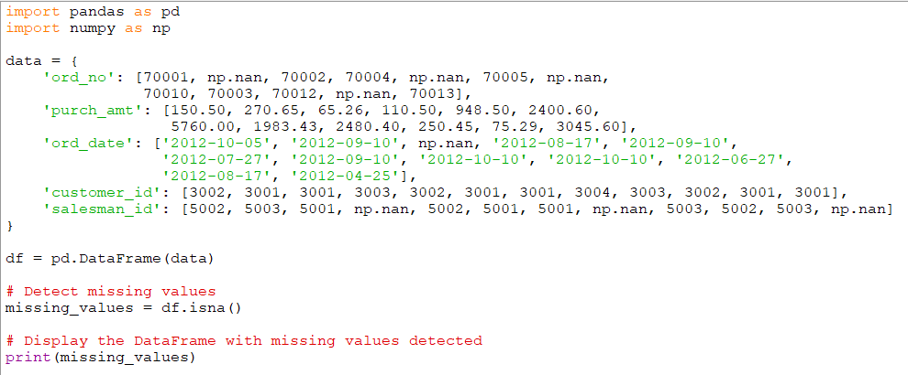

Output:

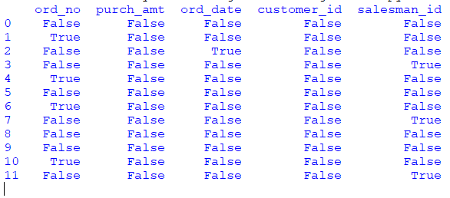

Experiment 14: Write a Pandas program to find and replace the missing values in a given DataFrame which do not have any valuable information.

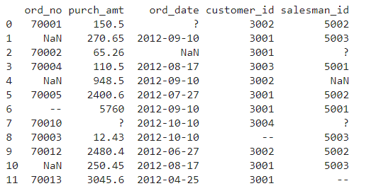

Program:

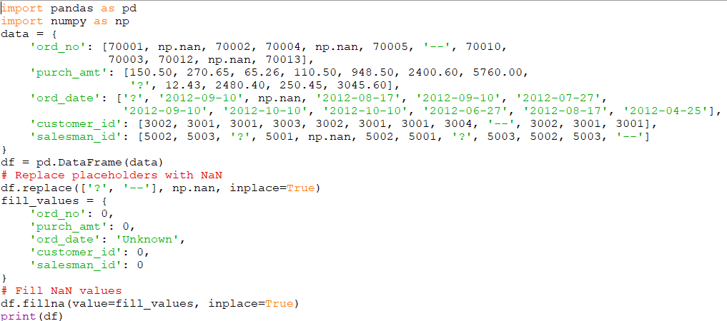

Output:

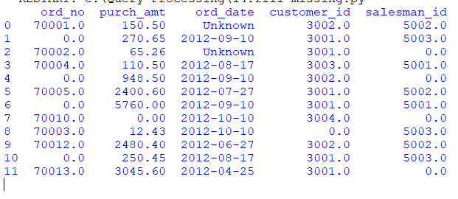

Experiment 15: Write a Pandas program to keep the rows with at least 2 NaN values in a given DataFrame.

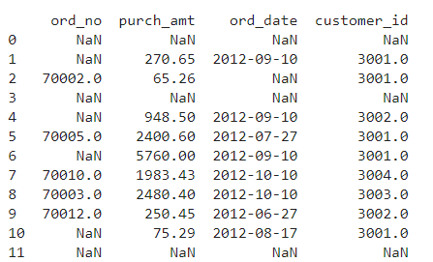

Program:

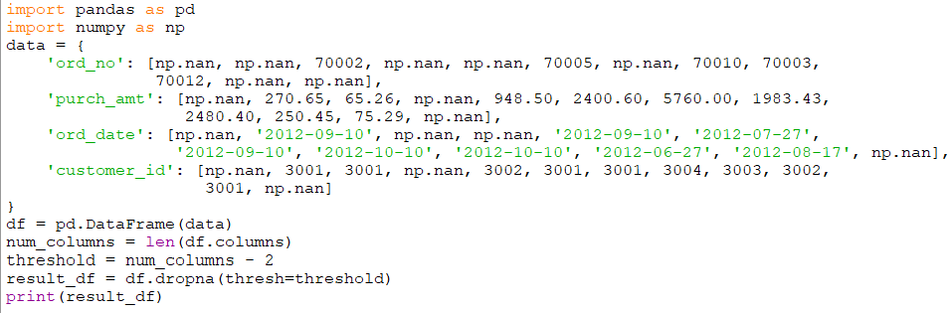

Output:

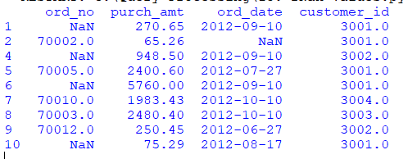

Experiment 16: Write a Pandas program to split the following dataframe into groups based on school code. Also check the type of GroupBy object.

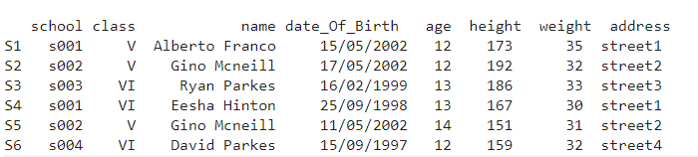

Program:

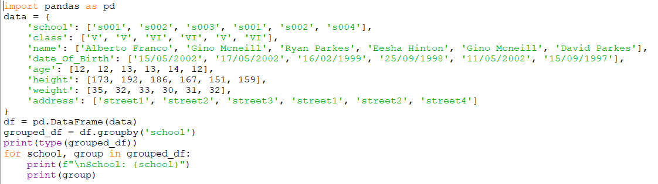

Output:

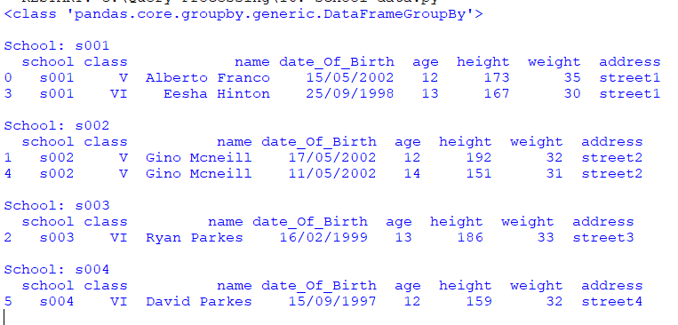

Experiment 17: Write a Pandas program to split the following dataframe by school code and get mean, min, and max value of age for each school.

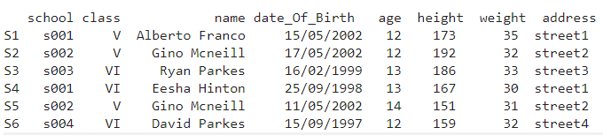

Program:

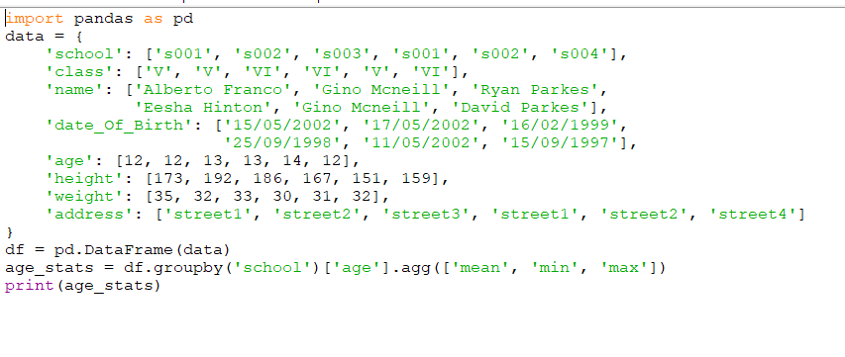Output:

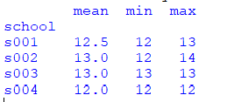

Experiment 18: Write a Pandas program to split the following given dataframe into groups based on school code and class.

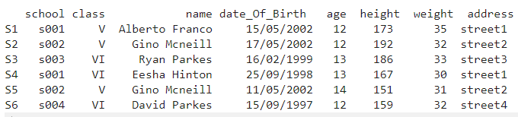

Program:



Output:

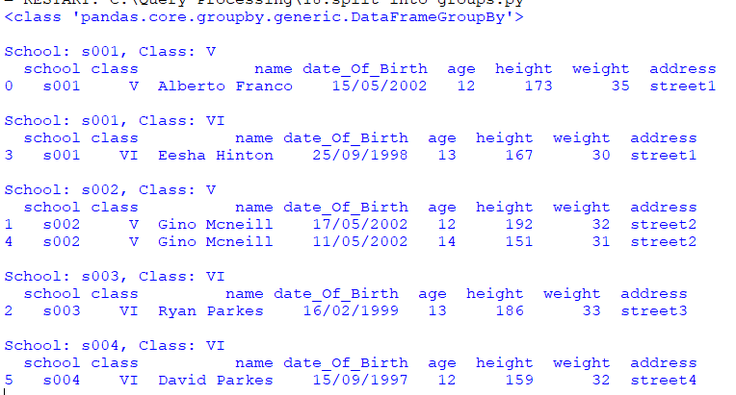

Experiment 19: Write a Pandas program to display the dimensions or shape of the World alcohol consumption dataset. Also extract the column names from the dataset

Program:

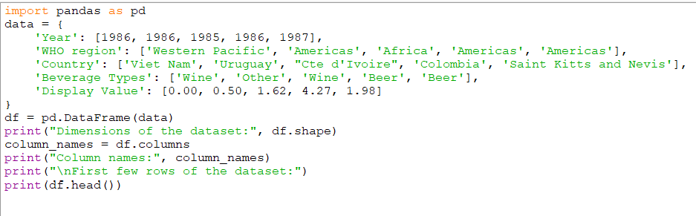

Output:

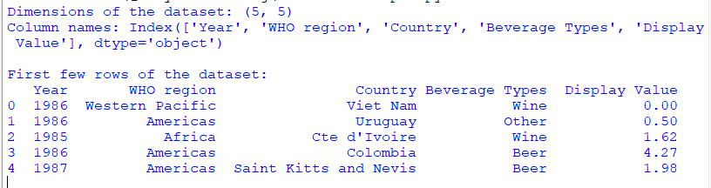

Experiment 20: Write a Pandas program to find the index of a given substring of a DataFrame column.

Program:

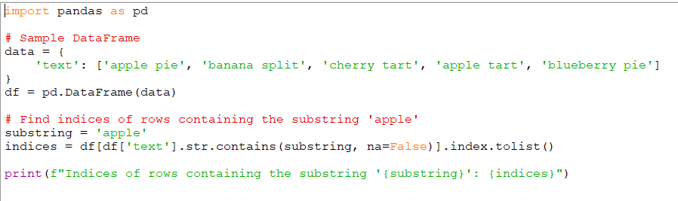

Output:

